**Week 7 Lab – Single Lab Only Task List Plugin**

**Task List WordPress Plugin Development Project**

* The Task List is designed as a WordPress plugin.
* Must be compatible with other WordPress plugins.
* Need a Task List Main page.
* Need an Add a Task List page.
* Need a Task List Settings page.
* Need a Task List Category page.
* A Task List must also appear on the WordPress Dashboard.
* Tasks and all associated fields must be able to be exported out of the system in full into a .csv file and imported into the system as .csv file. Importing a file into the system should not affect the status of completed tasks, deferred tasks, or irrelevant tasks.
* Must be able to set a standard group of tasks that would become part of the plugin, so to speak, and would be there every time the plugin was uploaded. I need the ability to set these and change them and all their fields of information. I want to be able to upload them into the plugin as a .csv file.
* Tasks should be searchable by keyword, date, date due, category, and who assigned to

Task List Display on WordPress Dashboard

* See mock up picture of WordPress Dashboard with Task List.
* The tasks that show on the dashboard are just today’s task list and should display no more than 10 tasks.
* All the tasks are listed on the Task List Main page (if there were more than 10 for the day, etc.).

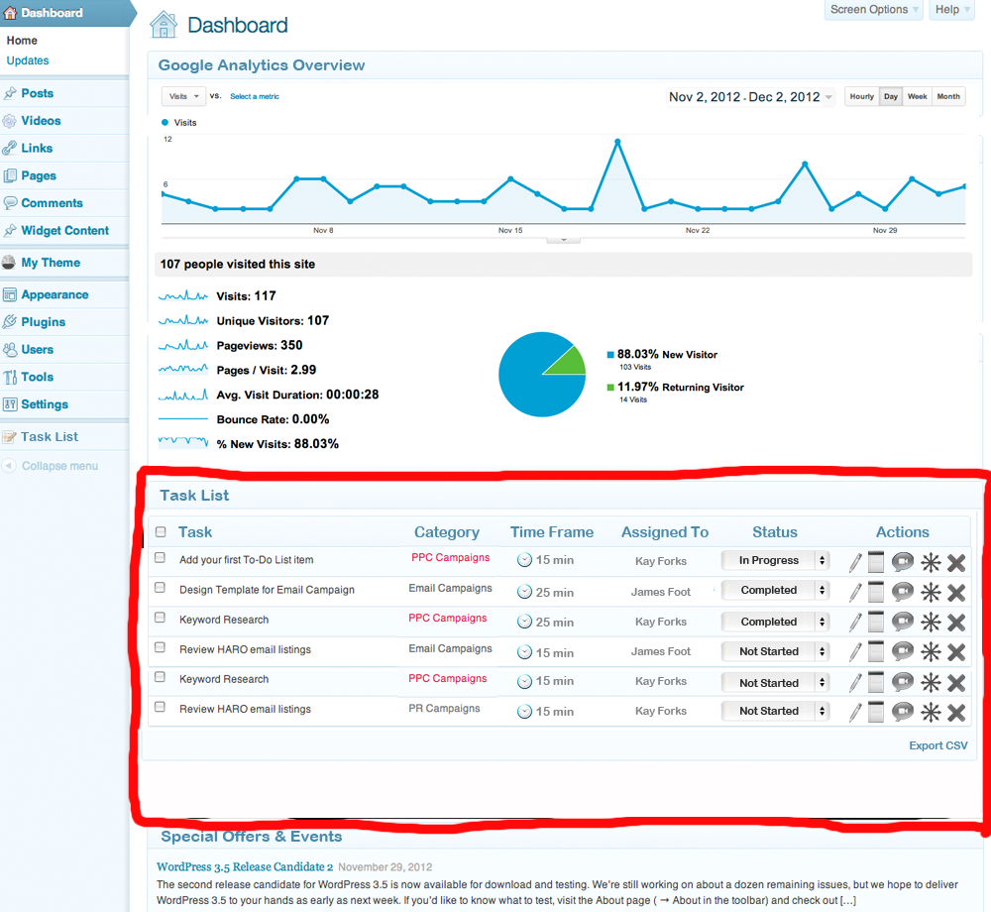Task List Settings Page:

* Please follow how Cleverness Task List plugin Version 3.2.2 by C.M. Kendrick works with various setup tasks and tabs. I would like similar layout and functionality. Picture included below.
* Should be able to assign each category to a user as the default. You should also be able to change that user within the Add a New Task or Edit Task functionality.
* Should be able to set how many of the preset tasks that will come with the plugin, you want to be presented on a daily basis (5, 10, 15, etc.). Any tasks that are created by the user should not be taken into account with this function. They should show regardless of whatever number is set here.

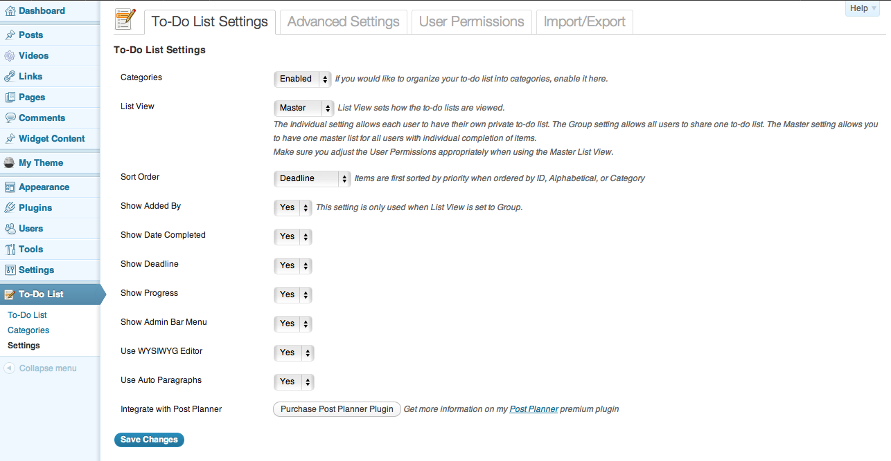

Task List Categories Page:

* Should follow a similar design style to the Cleverness Task List Plugin. Picture included below.
* Instead of a visibility dropdown with Public vs. Private, I want the ability to choose a user to be the default for each category. It should pull all the users for the website as choices, with the exception of myself “The URL Dr.” It should also have the default choice of All, which would show all tasks in that category to everyone.
* There should be a standard, set list of categories including: Website Design, SEO, PPC, PR, Social Media, Email, Affiliate, Analytics, Landing Pages, Content Creation, Blog. These will be loaded with the plugin.
* A new category should be able to be added from within this page by any user.

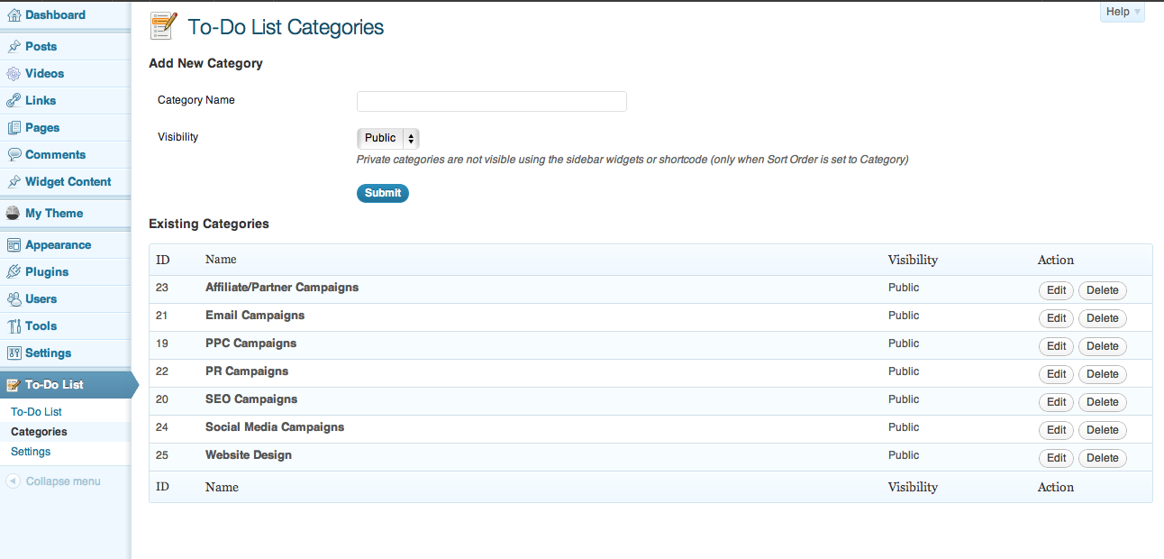

Task List Main Page:

* Should have the same general look and feel as any other top level WP admin page. (mockup provided)
* Add New task button at top of page. Opens to a “Add New Task” Page.
* Has the ability to change the view of the page between All tasks, Completed tasks, In Progress tasks, Irrelevant tasks, and Deferred tasks. Tasks should always be displayed sort in numerical order by the Task ID number.
* Bulk Actions should allow you to change the category, assigned to, status, or delete.
* Categories filter allows you to filter the view by categories. The results should always be displayed alphabetically by category first, and then by numerical order by the Task ID number.
* Search box allows you to search by keyword. Results should always be displayed in numerical order by the Task ID number.
* Headers (Category, Time Frame, Assigned To, and Status) when clicked should sort the items alphabetically by the different statuses first and then should be sorted in numerical order by the Task ID number.
* If the task name ends up being too many characters to fit in the field, it should wrap underneath to a second and/or third line, etc.
* Please ignore red font color in the category column in the mockup picture.
* There should also be a column for Priority: High, Medium, Low. High priority items should have the word “High” in red. You should be able to turn this column on and off in Screen Options. (not shown in mockup)
* There should also be a column for Date Due. You should be able to turn this column on and off in Screen Options. (not shown in mockup)
* “Assigned to” should be a column you can turn on and off in Screen Options.
* Action icons include a pencil for “Edit”, a notepad for “Notes”, a video camera for “Video”, a compass rose for “Directions”, and an X for “Delete.” When you hover over each icon it should have the alt tag set with those words to display. Edit should open to the same screen where you add a new task with the ability to change all the individual fields. Notes, Video, and Direction should open in a lightbox format over the page with a slightly grayed background. Notes should allow you to enter any kind of text to add to the task as a note. Video should play a video that is set in that task. Directions should open text directions. Each of these fields should be able to be filled in when creating a new task or uploading the task file. The Video field and the Directions field that is preloaded into the system should not be able to be changed by any user in the system other than “The URL Dr.”
* There should be an export to .csv file of the entire task list, including completed tasks. All fields of data should be included.
* There should be an import from a .csv file that would be for my admin purposes only and not available to the client. I want to be able to upload a large list of tasks that would be “pre-set” into the plugin for clients.
* The system should automatically log the date a task was completed and store this information. It should display when the view is changed to “Completed Tasks.”
* Tasks are viewed by the day. A user should be able to include a single day or multiple days from a drop down calendar (like on the Google Analytics report on the dashboard) to display. If there are more tasks that will display on a single page, there should be a navigation above the Task List so the user can go to page 2. The results should include any tasks that the user created with that date as a due date. It should also include however many tasks the user set in settings to be displayed each day, in the numerical order of the Task ID number. If the user set 10 tasks to be displayed, the system will pick the next 10 tasks by the next 10 Task ID numbers from the preset list to display. The following 10 tasks would appear on the following day and so on. When the time of day hits 12:00 AM, the date will turn over and if any tasks that are remaining with any status other than “Completed” the system will automatically forward them to the next day. With the daily turnover the system will prefill that day’s task list with the number of new tasks that meet the preset number from the settings page. For example, if the user had preset in settings that they wanted 10 tasks a day, and if all the tasks were completed on Monday, then Tuesday’s task list would include the next 10 tasks in the numerical order of the Task ID. If however, on Monday only 5 tasks were completed and the 5 uncompleted tasks were forwarded by the system to Tuesday, then only an additional 5 new tasks would be added to the task list.
* A task should have the option to be able to be made recurring. The recurring option should include daily, once a week, twice a month, or monthly and on what day. There should be an option of what date to start the recurring tasks and what date to stop the recurring tasks or for it to not have an ending date and just go on forever, or for a recurring task to start after a certain Task ID number was marked by the user as completed, deferred, or irrelevant. A recurring task would supercede a Task ID to show up in the daily task list.

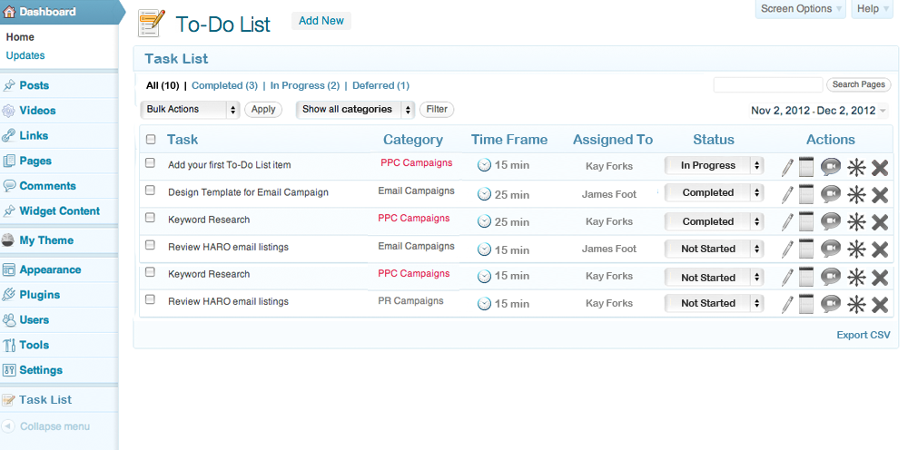

Add New Task Page:

* Similar layout to any “Add New” page in WordPress admin panel. I’ve provided a mockup as a reference, but I have not included all the fields outlined below.
* Needs to have “Task” field for the name of the task
* Needs to have “Category” field as a drop down with all the categories
* Needs to have “Time Frame” as a field to enter a number in minutes (10, 60, 120)
* Needs to have “Assigned to” as a drop down with all the users names available
* Needs to have “Status” as a drop down with “Not Started” as the default. Should include: “Not Started,” “In Progress,” “Completed,” “Irrelevant,” “Deferred.”
* Should have a field for notes.
* Should have a field for a url address of a video. Needs to be able to play YouTube and Vimeo videos.
* Should have a field for directions (WYSIWYG editor like in the mockup).
* Should have a dropdown for Priority: “High,” “Medium,” “Low”
* Should have a date field so you can enter a due date
* The system should automatically give each task and ID number. That ID number should be able to be made visible in Screen Options
* “To-Do List” in the mockup should read “Task List”
* Should have all the necessary recurring date fields an checkboxes as outlined in the last bullet point of the previous section.

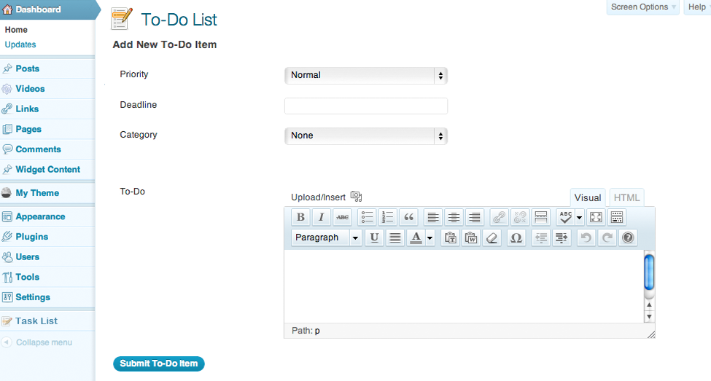

I saw your message yesterday but couldn't get back to you. Here are the answers, and if you need further clarification, let me know.

This plugin will likely come with a service and consulting contract, so the site owner will be doing tasks assigned to them by the consultant. The consultant will be sort of guiding the site owner and having them do consistent work toward SEO and social signals.

1. Preset tasks: The number of tasks that should show up on the dashboard widget. 5, 10, 15, etc. (However, any tasks the users or site owners create should not count toward this total). Here's an example: the consultant has 10 tasks in there and the settings page is set to 10. The user or site owner has entered 7 tasks. The dashboard widget should show the 10 that the consultant put in, PLUS the 7 the site owner put in.

2. Text Directions: Just have a small popup or something that shows the text directions field. It could even be a little balloon that pops open on hover.

Recurring Tasks: The idea here is that a task is likely to be repeated (post something to Twitter, share something on Facebook), so the site owner logs in on Monday, does the tasks and checks them off as complete. On Tuesday, when they login, they see anything that was set to repeat daily show up again as something they need to accomplish.

3. Recurring Tasks: this just means there should be checkbox options for the repeat times. For example:

_ Daily

_ Weekly

_ Twice a month

_ Monthly on ___ day